**Load & Stress tests**

1. **Expected Stress**The following rates are expected normal use of the system:
   1. Connection – 100 connections/sec
   2. Register – 20 new users/sec
   3. Login – 80 login actions/sec (80% of connections made, we expect to see mostly returning-users/store-managers)
   4. New Stores – 5 new stores/sec
   5. Purchases – 10 successful purchase/sec
2. **Stress Test – Plan of Attack**  
   In order to test the expected rates we will overload the system with a much higher rate of action.   
   This will help us see the actual limits of the system and allow us to see which areas are in need of improvement and optimization.   
   For each test we detail the initial state of the system, and how many actions of different types we perform:
   1. Connection:
      1. Initial active connections – 0
      2. Concurrent connections – 500
   2. Register:
      1. Initial registered users – 0
      2. Concurrent registrations – 150
   3. Login:
      1. Initial registered users - 1000
      2. Initial Login users – 0
      3. Concurrent login actions – 300
   4. New Stores:
      1. Initial logged in users – 20
      2. Number of new stores per user – 2
      3. Concurrent requests – 20
   5. Purchase:
      1. number of stores – 5
      2. number products per store – 5
      3. number of concurrent users trying to purchase 1 item per store – 20

Thus the expected success rate of purchase should be around 25%

1. **Test results**
   1. תמונה שמכילה טקסט, צילום מסך, תרשים

      התיאור נוצר באופן אוטומטיConnection:
   2. 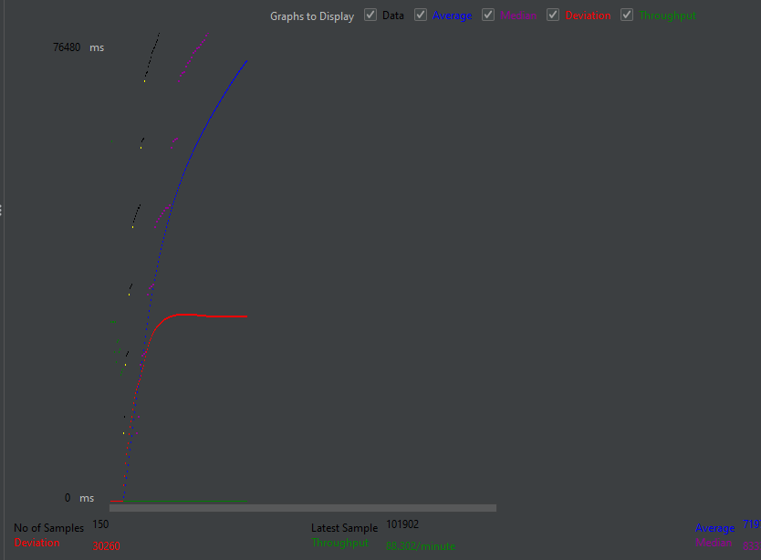Register:
   3. תמונה שמכילה צילום מסך, טקסט, תרשים

      התיאור נוצר באופן אוטומטיLogin:
   4. תמונה שמכילה טקסט, צילום מסך

      התיאור נוצר באופן אוטומטי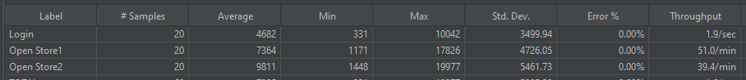New Store:
   5. 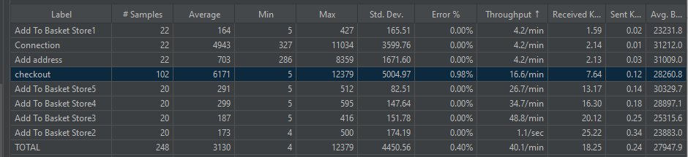Purchase